
CQPUSI Robot control system

User Manual
PMC006C3 Series
Miniature Integrated Stepper Motor Controller

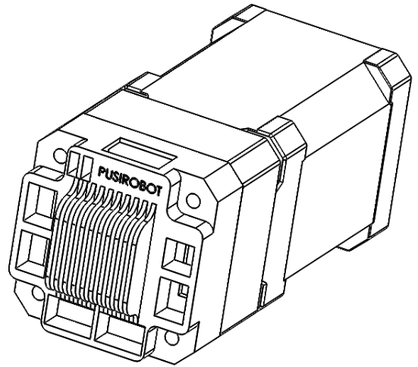

- Version Control
- Update Records
Date | Author | Version | Remark
2024/7/15 | Tony | V1.0.0 | Initial
2025/7/1 | Liu | V1.0.1

Catalog
1 Introduction 6
1.1 Statement of intellectual property right 6
1.2 Disclaimer 6
2 Overview 7
2.1 General Description 7
2.2 Features 7
2.3 Production & Ordering Information 8
3 Connector Description 9
3.1 Motor connection J7 9
3.2 Power connection J1 9
3.3 Solenoid valve connection J2 10
3.4 J3-communication port 1 10
3.5 J4-communication port 2 10
3.6 J5-limit connection 1 10
3.7 J6-limit connection 2 11
3.8 J9-encoder connection 11
3.9 CAN network connection 11
3.10 Limit switch connection 12
3.11 Mechanical switch connection 13
3.12 Analog Adjusting Speed /Position 13
3.13 Solenoid valve/brake connection 14
3.14 Drive mode selection 14
4 CANopen communication 15
4.1 CANopen introduction 15
4.2 CAN frame structure 15
4.3 CAN communication configuration 15
5 Detailed registers 16
5.1 System configuration 16
5.1.1 Node ID 16
5.1.2 Baud rate 16
5.1.3 Group ID 16
This object needs to be configured when using the synchronous run function. 16
5.1.4 Device node name 16
5.1.5 Hardware version 17
5.1.6 Software version 17
5.1.7 System control 17
5.2 Condition monitoring 17
5.2.1 Motor error status 17
5.2.2 Controller status 18
5.3 Micro stepping/Current 18
5.3.1 Micro stepping 18
5.3.2 Maximum phase current(Operating current) 19
5.4 Working mode switching 19
5.5 Position mode 20
5.5.1 Position mode rotating direction 20
5.5.2 Position mode start speed 20
5.5.3 Position mode stop speed 21
5.5.4 Position mode acceleration coefficient 21
5.5.5 Position mode deceleration coefficient 21
5.5.6 Position mode operating speed 22
5.5.7 Position mode relative displacement command 23
5.5.8 Position mode absolute displacement command 23
5.6 Stop stepper command 24
5.7 Commonly used parameters 24
5.7.1 Motor position 24
5.7.2 Zero Calibration(absolute value encoder closed loop) 24
5.7.3 Encoder position (absolute value encoder closed loop) 25
5.7.4 Current reduction 25
5.7.5 Motor enable 25
5.7.6 Stall stop setting(open-loop) 26
5.7.7 Stall parameters(open-loop) 26
5.7.8 Real-time speed(Closed-loop) 27
5.7.9 Temperature threshold 27
5.7.10 Motor wiring configuration 27
5.7.11 Automatic power-down save enabled 28
5.8 External emergency stop 28
5.8.1 External emergency stop enabled 28
5.8.2 The trigger mode of external emergency stop 28
5.8.3 Debouncing delay 29
5.9 General IO port 29
5.9.1 General IO port setting 29
5.9.2 General IO port value 30
5.10 Closed-loop parameter 31
5.10.1 Encoder resolution 31
5.10.2 KP parameter 31
5.10.3 KI parameter 32
5.10.4 KD parameter 32
5.10.5 Pre-filtering parameter 32
5.10.6 Post-filtering parameter 32
5.10.7 Stall length parameter 32
5.11 High-speed torque mode switch 33
5.12 Open loop application switch 33
5.13 PP mode 34
5.13.1 PP mode parameter 1 34
5.13.2 PP mode parameter 2 35
5.13.3 PP model work timing 36
5.14 Synchronous position Motion mode 39
5.14.1 SP speed 39
5.14.2 SP position 39
5.14.3 Synchronous start and stop 39
5.15 Analog positioning 40
5.15.1 Analog positioning enabled 40
5.15.2 Analog initial AD code 40
5.15.3 Analog adjustment interval 41
5.15.4 Analog regulating trigger value 41
5.15.5 Minimum value of analog position 41
5.15.6 Maximum value of analog position 41
5.16 offline programming 41
5.16.1 Offline programming parameter 1 41
5.16.2 Offline programming parameter 2 42
5.17 Brake control 43
5.18 Analogue input read 43
5.19 Step notification 43
5.20 Low-voltage protection 44
5.20.1 Low-voltage protection control word 44
5.20.2 Offline voltage threshold 44
5.20.3 Brake voltage threshold 45
6 User-defined programs 45
7 Tool software operation introduction 45
7.1 Graphic programming support 45
7.2 Scripting language support 46
8 Electrical Characteristics 46
9 Dimensions 47
10 Appendix 1 PMC006C3 Object dictionary table 48
Analog initial AD code 56
11 Appendix 2 CANopen Communication Examples 57
11.1 SDO Read/Write Examples 57
11.1.1 SDO Read 57
11.1.1.1 Data frame format 57
11.1.1.2 SDO Read example 58
11.1.2 SDO Write in 58
11.1.2.1 Data frame format 58
11.1.2.2 SDO Write example 59
12 Appendix 3 PDO configuration example 60
12.1 PDO overview 60
12.1.1 The structure PDO——Mapping parameter 60
12.1.2 The structure PDO——Communication parameter 61
12.1.3 PDO Trigger mode 62
12.2 PDO Configuration example 63
13 Appendix 4 SDO abort code error 64

Introduction

Statement of intellectual property right
PMC006C3 series controller has been applied for the following national patent:
• Controller scheme and method have been applied for the protection of the invention patent.
• Controller circuit has been applied for the protection of utility model patent.
• Controller appearance has been applied for the protection of appearance patent protection.
PMC006C3 series controller has embedded firmware code, it would be considered as a violation of intellectual property protection act and regulations that any behavior of trying to destroy the function of firmware code protection. If this behavior acquires the software or other achievements of intellectual property protection without authorization of CQPUSI, CQPUSI has the right to stop such behavior by filing a lawsuit according to the act.

Disclaimer
The using method of the device and other content in the description of this manual is only used to provide convenience for you, and may be update in futu-re version. To ensure the application conforms to the technical specifications is the responsibility of your own. CQPUSI does not make any form of statement
or guarantee to the information, which include but not limited to usage, quality, performance, merchantability or applicability of specific purpose. CQPUSI is not responsible for these information and the consequences result caused by s-uch information. If the CQPUSI device is used for life support and/or life saf-ety applications, all risks are borne by the buyer. The buyer agrees to protect the CQPUSI from legal liability and compensation for any injury, claim, lawsu-it or loss caused by the application.

Overview

General Description
PMC006C3 is a kind of miniature integrated stepper motor microstepping controller, which can be directly installed in the rear of NEMA17/23 series stepper motor. The PMC006 series controllers are available in a variety of models based on CAN bus control and different current levels. With the PMC006C3 stepper motor controller, it is easy to implement an industrial control network system with up to 120 nodes, and encoder-based closed-loop control can be realized according to user requirements. PMC006C3 adopts the industry standard CANOPEN DS301 control protocol, which is suitable for a variety of high-precision, wide-range industrial applications.

Features
- Wide range of 9-36V single voltage supply
- Output current 0.2A ~ 3A. Adjustable phase current by commands
- Automatic control of S curve acceleration and deceleration
- Support Position/Velocity/PP/PV/SP/Analog Position/Analog velocity mode etc. motion mode
- Support 200-8000PPR incremental encoder; Supports single-turn and multi-turn absolute encoders;
- Support automatic deviation correction;
- Support normal open-loop mode, normal closed-loop mode, closed-loop high-speed torque mode
- Electromagnetic brake control function
- Sensor-less stall detection
- LUA script programming support
- Power-down detection
- Support 0/2/4/8/16/32/64/128 microstepping resolution
- Suitable for 4/6/8 lines of 2 phase stepper motor
- Automatic over-temperature, over-current, under-voltage and overvoltage protection
- Analog Input Application (Special edition)
- Hot-plug protection, power misconnection protection
- Miniature size 42mmx42mmx18mm

Production & Ordering Information
In order to serve you quicker and better, please provide the product number in following format when ordering PMC006C3：
PMC |  | 006 |  | C |  | 3 |  | E
 |  |  |  |  |  |  |  |  | Peak Current：3=3A
 |  |  |  |  |  |  |  |  | Bus： CAN Bus
 |  |  |  |  |  |  |  |  | Model
 |  |  |  |  |  |  |  |  | PUSI Motor Controller

Remark:
E：Closed-loop type.

Connector Description
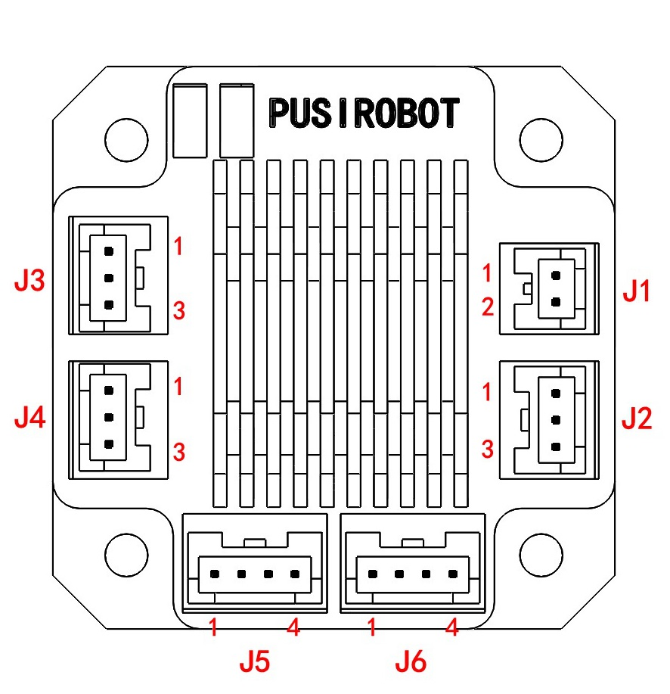
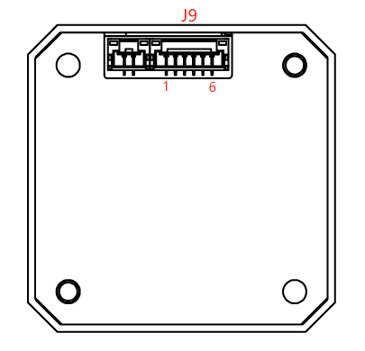

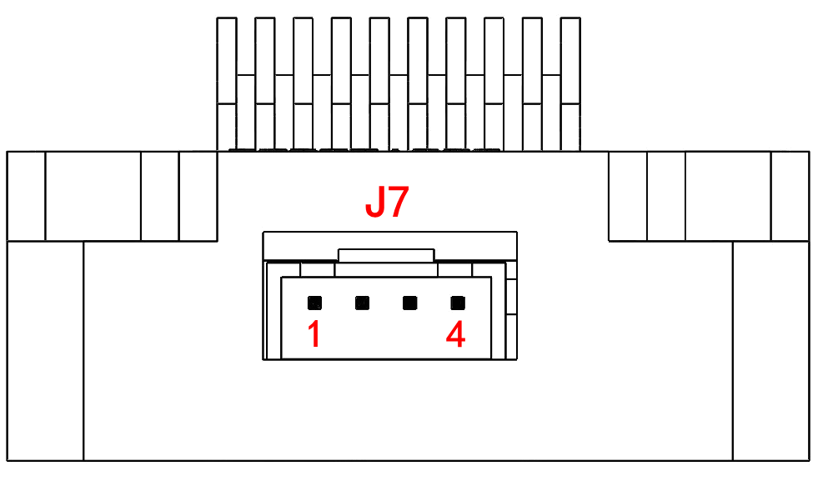

Motor connection J7
Pin no | 1 | 2 | 3 | 4
Designator | M10 | M11 | M20 | M21

Description:
M10: Motor A+ phase M11: Motor A- phase
M20: Motor B+ phase M21: Motor B- phase

WARNING: The wrong phase wire of the power supply or motor can permanently damage the controller ( For closed-loop, correspond to the red, blue, black, and green wiring)

Power connection J1
Pin no: | 1 | 2
Designator | GND | VCC

Description:
VCC：Supply voltage, 9-36V.
GND：Supply voltage ground.

Solenoid valve connection J2
Pin no: | 1 | 2 | 3
Designator | Coil- | Coil+ | NC

Description:
Coil+：Solenoid valve/brake positive control terminal, its voltage is equal to the voltage of power supply
Coil-：Solenoid valve/brake negative control terminal;
NC: Reserved port, no function

Warning: The Coil pin is the same as the supply voltage, be careful not to short with DVDD, GND, or other signal lines

J3-communication port 1
Pin no: | 1 | 2 | 3
Designator | GND | CANH | CANL

Description:
CANH: Connect the transceiver interface of the CAN module
CANL: Connect the transceiver interface of the CAN module
GND: Controller digital ground

A single unit only connected to one communication port, when networking, directly plug in the access bus by using communication port

J4-communication port 2
Pin no: | 1 | 2 | 3
Designator | GND | CANH | CANL

Description:
CANH: Connect the transceiver interface of the CAN module
CANL: Connect the transceiver interface of the CAN module
GND: Controller digital ground

J5-limit connection 1
Pin no: | 1 | 2 | 3 | 4
Designator | DVDD | GND | EXT1- | EXT1+

Description:
DVDD：Controller voltage output(+5V). Maximum current is 100mA.
GND：Controller digital ground.
EXT1+：External limit switch signal input 1 positive, 3~5.5V.
EXT1-：External limit switch signal input 1 negative

J6-limit connection 2
Pin no: | 1 | 2 | 3 | 4
Designator | OUT-VDD | GND | EXT2- | EXT2+/AN

Description:
OUT-VDD: GPIO8 controlled 5V output, 50mA max
GND：Controller digital ground.
EXT2-：External limit switch signal input 2 negative
EXT2+：External limit switch signal input 2 positive, 3~5.5V.
AN: Can be used as an analog input interface in the special version, input voltage 0-3.3V.
Can be 0-24V (or 10mA) input in the special version.

Note: The analog input and the second limit port can only be realized by selecting one of the two functions.

J9-encoder connection
Pin no: | 1 | 2 | 3 | 4 | 5
Designator | DVDD | GND | A | B | Z

Description:
DVDD：Controller voltage output(+5V). Maximum current is 100mA.
GND：Controller digital ground.
A: Encoder phase A signal
B: Encoder phase B signal
Z: Encoder phase Z signal

CAN network connection
Transmission distances of up to 5,000 meters can be achieved using a CAN bus connection. Figure 3-4 provides a network solution consisting of multiple PMC006C3 controllers connected by a CAN bus, which is compatible with CAN2.0A and CAN2.0B, and can connect up to 127 nodes.
Note: It is recommended to use a 120 ohm shielded twisted pair dedicated to the CAN bus and to connect a 120 ohm termination resistor at each end of the twisted pair.
PMC006C3 supports the standard CANopen DS301 protocol, CQPUSI provides a special debugging tool software for PMC006C3 networking, PUSICAN, which currently supports a variety of mainstream brands of USB2CAN modules on the market.

Limit switch connection
The PMC006C3 controller has two special pins EXT1/EXT2 for connecting external limit switches, the trigger mode of each pin can be selected in real time through the command, the factory default value is valid for the falling edge trigger, at this time, the corresponding EXT1/EXT2 is from high level to low level jump, there is optodephone isolation inside the controller, when the optocoupler input positive and input negative correctly form a loop, and are in the normal conduction state, then EXT1/EXT2 will change from high level to low level, Figure below.

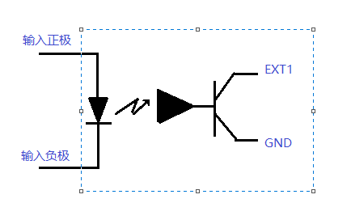
Input positive
Input negative

There are two types of common external limit switches, one is a four-wire through-beam optocoupler without an internal circuit, and the other is a three-wire or five-wire optocoupler with an internal circuit, which is divided into PNP type and NPN type. And there is a difference between light conduction and shading conduction. For different types of optocouplers, you can refer to the following wiring methods:

- NPN type three-wire optocoupler
When the light is in, it is turned on and the occlusion is triggered, and the rising edge trigger mode is configured, as shown in Figure below. Note that in this case, EXT1/EXT2 both need the OUT-VDD pin of J6 as the power supply. If the DVDD pin of J5 is used, an external current-limiting resistor is required to avoid burning the light-emitting diode of the optocoupler.
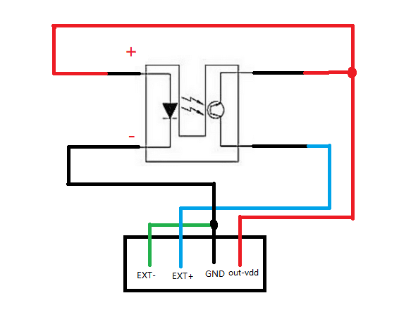

- NPN type three-wire optocoupler
When entering the light, it is turned on and the occlusion is triggered, and it is configured as the rising edge trigger mode
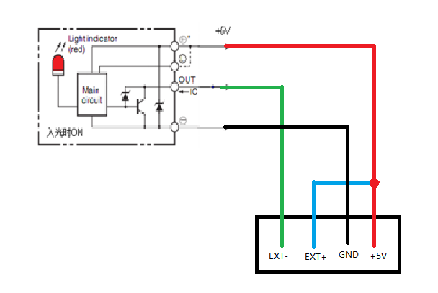
- PNP type three-wire optocoupler
When entering the light, it is turned on and the occlusion is triggered, and it is configured as the rising edge trigger mode
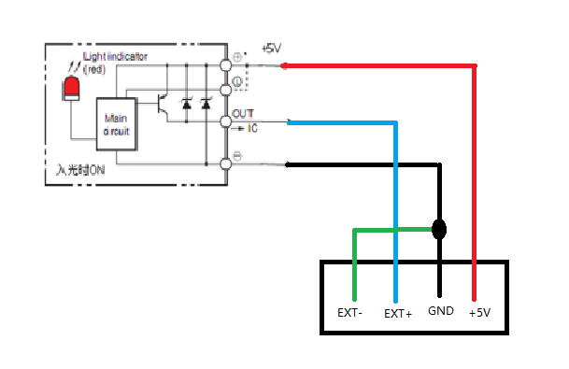

Mechanical switch connection
When using mechanical button switch or relay contact as a limit, it should be directly connected, EXT access DVDD, EXT- access GND, usually not conduction, press on, configure as the descending edge trigger mode. As shown in the figure below.

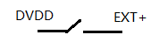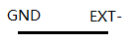

Analog Adjusting Speed /Position
In the special version, the PMC006C3 controller can use the analog speed regulation function and the analog positioning function in offline operation mode. In this case, the AN pin is used as an analog input port, so please contact sales in advance if you need to purchase it.
In offline mode, the AN pin is used as an analog input port in this application, which can be directly connected to an external input voltage in the range of 0~3.3V. When using PLC or other industrial control equipment to output 4~20mA or 0-24V analog control, special instructions are required to distinguish the version.
Analog speed regulation: Set a speed range, the minimum value corresponds to the input minimum value, and the maximum speed value corresponds to the input maximum value. By adjusting the input value, the motor rotates at the corresponding speed.
Analog positioning: Set a position range, the minimum value of the position corresponds to the minimum value of the input, and the maximum value of the position corresponds to the maximum value of the input. The current position of the motor is adjusted to change the input value so that the motor stops at the specified position. Values such as speed are fixed when set.

Solenoid valve/brake connection
The PMC006C3 controller supports direct control of inductive loads such as solenoid valves, solenoids, solenoid brakes, and DC motors. As shown in the figure below, the load can be connected to the Coil and Coil- pins on the controller J1. The output voltage is the same as the input power supply voltage of the controller, and the output current is up to 800mA, in order to reduce the working temperature of the load coil, the controller supports PWM dynamic voltage adjustment function, and the user can modify the output voltage in real time through instructions.
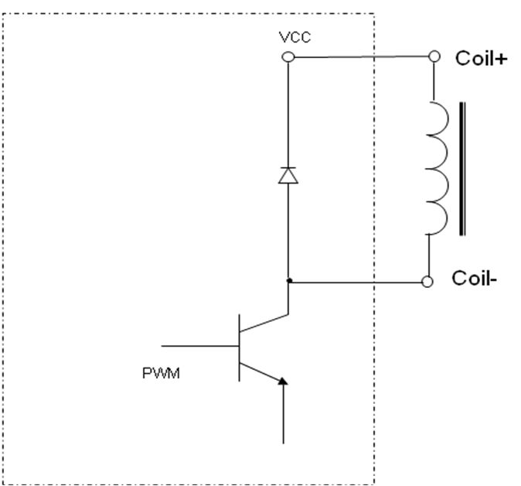

Drive mode selection
1. Normal open-loop/ordinary closed-loop mode. The applicable speed range is 10-1200RPM;
2. Closed-loop high-speed torque mode, by modifying the value switch of the 0x6015, when using the mode, the controller will automatically set the microstepping, which cannot be changed manually, the unit of the acceleration and deceleration running parameters is changed, the applicable speed range is 1000-5000RPM, with automatic deviation correction function, default mode.
3. Analog speed regulation/analog positioning mode, you need to use offline programs and analog input ports together.

CANopen communication

CANopen introduction
CAL provides all network management services and messaging protocols, but does not define the content of the object or the type of object being communicated (it only defines how, not what), which is where CANopen comes in. CANopen is developed on the basis of CAL, using a subset of CAL communication and service protocols to provide an implementation of a distributed control system. CANopen allows the nodes to be scaled at will: simple or complex, while ensuring the interoperability of the network nodes.
The core concept of CANopen is the Object Dictionary (OD), which is also used in other fieldbus (Profibus, Interbus-S) systems. CANopen communication provides access to all parameters of the drive via the Object Dictionary (OD). Note: The object dictionary is not part of the CAL, but is implemented in CANopen, and the PMC006C3 supported object dictionary is shown in Appendix I.
The CANopen communication model defines the following types of messages (communication objects):
Abbreviation | Full name | Description
SDO | Service Data Object | Used for non-time critical data, such as parameters.
PDO | Process Data Object | Used to transfer time critical data(Setting values, Control word, status information, etc.)
SYNC | Synchronization Message | Used to synchronize CAN nodes.
EMCY | Emergency Message | Used to transport alarm event of a driver.
NMT | Network Management | Used for CANopen network management.
Heartbeat | Error Control Protocol | Used for monitoring the life status of all nodes.

CAN frame structure
CAN Data is transmitted between the host (controller) and the bus node through the data frame. The following table is the structure of the data frame.
Header | Arbitration domain |  | Control domain | Data domain | Check field | Response domain | Tail frame
Header | COB-ID(communication object identifier) | RTR(remote request)
1bit 11 or 29 bits 1bit 6bits 0~8byte 16bits 2bits 7bits

CAN communication configuration
PMC006C3 factory default settings: node ID is 3/5, the baud rate is 125Kbit/s. The user can modify the settings by supporting the CANOPEN master debugging tool.

Detailed registers

System configuration

Node ID
Object name | Node ID
SDO ID | 0x2002
Object type | U8,rw
Range | 1-127
Storage type | ROM
Default value | 3/5

Baud rate
Object name | Baud rate
SDO ID | 0x2003
Object type | U8,rw
Range | 0,1,2,3,4,5,6,7,8
Storage type | ROM
Default value | 4
Relationship between each index and the baud rate is as follows:
0：20Kbit/s
1：25Kbit/s
2：50Kbit/s
3：100Kbit/s
4：125Kbit/s
5：250Kbit/s
6：500Kbit/s
7：800Kbit/s
8：1000Kbit/s

Group ID
Object name | Group ID
SDO ID | 0x2006
Object type | U8,rw
Range | 1-127
Storage type | ROM
Default value | 0

This object needs to be configured when using the synchronous run function.

Device node name
Object name | Device node name
SDO ID | 0x1008
Object type | string,ro
Range | -
Storage type | ROM
Default value | -

Hardware version
Object name | Hardware version
SDO ID | 0x1009
Object type | string,ro
Range | -
Storage type | ROM
Default value | -

Software version
Object name | Software version
SDO ID | 0x100A
Object type | string,ro
Range | -
Storage type | ROM
Default value | -

System control
Object name | System control
SDO ID | 0x2007
Object type | U8,ro
Range | 1，2，3
Storage type | RAM
Default value | -
System control values are defined as follows:
1: Jump to bootloader
2: Save Object Dictionary parameters(i.e. power down save command)
3: Reset factory settings
Note: the Storage type in the Object Dictionary which is ROM parameter is temporarily stored in memory after written by SDO. If you need to keep it permanently, you need to perform power down save operation for the Object Dictionary parameter.

Condition monitoring

Motor error status
Object name | Error status
Instruct address | 0x6000
Object type | U8,rw
Range | bit
Storage type | RAM
Default value | 0
Driver state are defined as follows:
Bit0：OTS, over temperature shutdown
Bit1: AOCP, motor over-current
Bit2: BOCP, magnetic core position error
Bit3: APDF, Wrong direction of rotation when facing magnetism
Bit4: BPDF, Wrong rotation angle when facing magnetism
Bit5: UVLO, low supply voltage warning
Bit6: SERR, encoder packet error
Bit7: EERR, encoder position error
Clear the corresponding error state by writing 1 to the corresponding bit, for example, write 18 00 00 00 to clear the flags of bit3 and bit4, that is, to clear the wrong rotation direction when facing the magnet and the wrong rotation angle when facing the magnet, and write FF to be fully clear.
Note: bit2/bit3/bit4/bit6/bit7 only takes effect for high-speed torque mode.

Controller status
Object name | Controller status
Instruct address | 0x6001
Object type | U8,rw
Range | bit
Storage type | RAM
Default value | 0
Controller status is defined as follows:
Bit0：External stop 1
Bit1：External stop 2
Bit2：Stall state
Bit3：busy state
Bit4：External stop 3
Bit5：The FIFO of PVT mode 3 is empty
Bit6：Lower FIFO limit for PVT mode 3
Bit7：Upper FIFO limit for PVT mode 3
In addition to the busy state, you can write 1 to clear the response state, and the usage is the same as 6000h.

Micro stepping/Current

Micro stepping
Object name | Micro stepping
Instruct address | 0x600A
Object type | U16,rw
Range | 0,2,4,8,16,32,64, 128
Storage type | ROM
Default value | 32
Only parameters within the range can be configured, and other values are outliers.

Maximum phase current(Operating current)
Object name | Maximum phase current
SDO ID | 0x600B
Object type | U16,rw
Range | 0-6000
Storage type | ROM
Default value | 0
The maximum phase current is the supply current to the motor during normal operation, usually set to the rated current of the motor. In some cases, adjustments can be made appropriately, with a general range of+-20% and not exceeding 50%. Excessive current can cause severe heat generation in the motor, and prolonged operation of the motor may pose a risk of demagnetization, affecting its lifespan. Unit: mA

Working mode switching
Object name | Working mode switching
SDO ID | 0x6005
Object type | U8,rw
Range | 0,1,4,5
Storage type | RAM
Default value | 0
The values of the motor operating mode are defined as follows:
0: Position mode
1: Velocity mode (including analog speed regulation)
4: PP (Profile Position) mode (including analog positioning)
5: PV (Profile Velocity) mode
Position Mode:
The setting of the position mode is simple, easy to operate, you can use the relative or absolute running motion mode, after setting the running speed and direction of movement, give the corresponding running instructions, the motor will move to the corresponding position, because the acceleration and deceleration is the gear setting, the acceleration and deceleration can not be accurately adjusted, the equipment or parameters need to be debugged according to the load situation, the stepping command setting needs to be sent when the controller is idle, so to change the speed, change the stepping position, you need to wait for the motor to stop and then send the corresponding instructions, before it can run, Otherwise, the command will not be received.
Velocity Mode:
After entering the velocity mode, set the running speed and the motor will rotate all the time. Unless the limit or stop stepping command is triggered or the speed mode is exited, the motor will rotate according to the running speed, and the running speed can be changed (positive positive rotation, negative negative reversal) and speed adjustment can be adjusted by setting the running speed during operation, without stopping the movement. The velocity mode and the position mode share the same parameter register, and the acceleration and deceleration and start-stop speed cannot be modified during operation. The velocity mode is easy to set and stable, which is convenient for long-distance variable speed movement. If it is at high speed, changing direction directly may cause stalling. The speed setting needs to be adjusted according to the actual operation.
PP Mode:
PP mode uses trapezoidal acceleration and deceleration movement, each run can change the acceleration and deceleration, start and stop speed, running speed, running direction and target position, through the unified execution of the control word, you can switch the running task or preset the next task during the movement. PP mode can also use absolute or relative operation modes, and the acceleration and deceleration value settings are open to better control the smoothness of the operation and perform more complex operation planning.
PV Mode:
PV mode is called Profile Velocity Mode, which also uses trapezoidal acceleration and deceleration mode, and shares parameters such as start-stop speed, acceleration and deceleration, and running speed with PP mode. After entering PV mode, you need to set the running speed for the first run, use the control word to start the run, and then change the speed only need to modify the value of the running speed.
During PV mode operation, the motor will rotate according to the set running speed, and the stop can be achieved by exiting or switching the mode/setting the running speed to 0/step stop command. During the operation, the running speed can be set to change the running direction (positive positive rotation, negative negative reversal) and adjust the speed magnitude, without pausing the movement to set the parameters. Because the acceleration and deceleration are controllable and the acceleration and deceleration are uniform, it is easier to calculate the running time, and changing the running direction at high speed will not cause stalling

Position mode

Position mode rotating direction
Object name | Rotating direction
Instruct address | 0x6002
Object type | U8,rw
Range | 0,1
Storage type | RAM
Default value | 1
The value of the rotation direction is defined as follows:
0: forward
1: backward

Position mode start speed
Object name | Start speed(Unit: pps)
Instruct address | 0x6006
Object type | U16,rw
Range | 0-0xFFFF
Storage type | ROM
Default value | 600

Position mode stop speed
Object name | Stop speed(Unit: pps)
Instruct address | 0x6007
Object type | U16,rw
Range | 0-0xFFFF
Storage type | ROM
Default value | 600
If the start speed and stop speed jump directly, for example, jump from 0 to the maximum speed of starting speed and then accelerate or decelerate from maximum speed to stop speed and then jump to 0, so the start and stop speed cannot be set to 0.
The start-stop speed of the 600 can be adapted to most operating scenarios, and it can be switched when it needs to be started faster or run at a lower speed, and the rest of the time the RPM is configured using microstepping and speed settings.

Position mode acceleration coefficient
Object name | Acceleration coefficient
Instruct address | 0x6008
Object type | U8,rw
Range | 0-8
Storage type | ROM
Default value | 8

Position mode deceleration coefficient
Object name | Deceleration coefficient
Instruct address | 0x6009
Object type | U8,rw
Range | 0-8
Storage type | ROM
Default value | 8
Figure 5-1
The Position mode uses S curve acceleration and deceleration. As shown in Figure 5-1, the start-up speed, stop speed, acceleration and deceleration can be configured separately, and the acceleration and deceleration support 1~8 for a total of 8 gears, and the corresponding acceleration values for each gear are as follows.PMC006C3 The acceleration value of the 1st gear is the largest, and the acceleration value of the 8th gear is the smallest.

Gear | Acceleration and deceleration value（PPS2）
0 | Acceleration and deceleration cannot be enable
1 | 77440
2 | 48410
3 | 27170
4 | 21510
5 | 14080
6 | 10460
7 | 6915
8 | 5210

Position mode operating speed
Object name | Position mode operating speed（pps）
Instruct address | 0x6003
Object type | S32,rw
Range | -200000 ~ +200000
Storage type | RAM
Default value | 0
Note: the speed is a signed variable. Positive represents that the direction is 1, and negative represents that the direction is 0. So in the displacement mode it is recommended to set the speed firstly , and then set the direction.
The RPM per minute and the microstepping of the set, as well as the magnitude of the speed value, are as follows:
RPM = (PPS*60)/ (200*microstepping)
Similarly, the rotational speed per second is:
RPS = PPS / (200 * microstepping)

Position mode relative displacement command
Object name | Relative displacement command
Instruct address | 0x6004
Object type | U32,rw
Range | 0x0-0xFFFFFFFF
Storage type | RAM
Default value | 0
Relative to the current motor position, let the motor run for a set number of steps, and an error will be reported if the displacement is 0. Write step number, then the controller will control the motor rotate a given number of steps which is calculated based on the current microstepping settings at the setting direction, speed and acceleration.
In open-loop mode, the number of steps is calculated based on the current microstepping setting.
In the incremental encoder closed-loop mode, the input unit is 4 times the resolution of the encoder, for example, CPR=4000, then the motor rotates once when 16000 is input.
In the closed-loop mode of the absolute encoder, the input unit is the same as the encoder counting unit, for example, if the accuracy is 14 bits, then the motor rotates once when 16384 is entered.

Position mode absolute displacement command
Object name | Absolute displacement command
Instruct address | 0x601c
Object name | S32,rw
Range | Incremental or single-turn absolute encoder:-2^31 ~ (2^31-1)  Multi-turn absolute encoder:-2^31 ~ (2^31-1)
Storage type | RAM
Default value | 0
The absolute displacement command gives the target position, and the controller will automatically calculate the direction and the required number of steps, and control the stepper motor to rotate to the specified position according to the set speed and acceleration.
In open-loop mode, the number of steps is calculated based on the current microstepping setting.
The number of pulses is calculated in the same way as the relative displacement command.

Stop stepper command
Object name | Stop stepper command
Instruct address | 0x6020
Object type | U8,rw
Range | 0
Storage type | RAM
Default value | 0
I

The command immediately terminates the operation of the motor, there is no deceleration process, and it can take effect by writing 0.

Commonly used parameters

Motor position
Object name | Motor position
Instruct address | 0x600C
Object type | S32,rw
Range | Incremental or Singleturn Absolute Encoder: -2^31 ~ (2^31-1)  Multiturn absolute encoder: -2^31 ~ (2^31-1)
Storage type | RAM
Default value | 0
The current motor position is represented by the conversion of the number of pulses per revolution. The incremental type is a quadruple of the PPR, for example, 4000 lines are 16000 pulses for one revolution of the motor. The absolute accuracy is 2^14,16384 pulses per revolution.
In open-loop mode, the motor position is not saved, and the position information is automatically cleared to zero after the controller is powered off.
In incremental closed-loop mode, motor positions are not saved for conventional applications. There is a switch inside the controller that can record the position of the motor before the power is off. It is generally used in conjunction with the brake to prevent the motor from moving in the event of a power failure. Otherwise, the saved location is not referential.
In the closed-loop mode of absolute single-turn value, the controller can record the change of motor position within one turn, and the value of the extra turn will be automatically discarded after the power failure. Values greater than one turn are saved, and you can refer to the same application method as the incremental type.
Multi-turn absolute closed-loop mode, which can record the change of motor position in real time, and can still work after power failure. The position of the limit switch can be omitted.

Zero Calibration(absolute value encoder closed loop)
Object Name | Zero Calibration
Instruct address | 0x6034
Instruct address | S32,rw
Object type | Single-turn absolute encoder：-2^31 ~ (2^31-1)  Multi-turn absolute encoder：-2^31 ~ (2^31-1)
Range | RAM
Storage type | 0
The controller of the absolute value encoder closed-loop supports this object, and when the user writes the value of a motor position (0x600C object), the value of the zero calibration is automatically calculated, the motor position read by the user = the encoder position + zero calibration .

Encoder position (absolute value encoder closed loop)
Object Name | Encoder position
Instruct address | 0x6035
Instruct address | S32,rw
Object type | Single-turn absolute encoder：-2^31 ~ (2^31-1)  Multi-turn absolute encoder：-2^31 ~ (2^31-1)
Range | RAM
Storage type | 0
For now only single-turn and multi-turn value reading is open, and the encoder feedback position is read in real time, and the value cannot be changed by command.
Currently, only absolute encoder readings are available.

Current reduction
Object name | Current reduction coefficient
Instruct address | 0x600D
Object type | U8,rw
Range | 0-3
Storage type | ROM
Default value | 2
The value is defined as follows:
0：Decay 0%;
1：Decay 50%
2：Decay 75%
3：Decay 87.5%
0-3 corresponds to 4 gears of 100%, 50%, 25% and 12.5% idle current supply, the ratio is based on the percentage of the maximum phase current of 600Bh. The default is 50% for 2nd gear.

Motor enable
Object name | Motor enable
Instruct address | 0x600E
Object type | U8,rw
Range | 0,1
Storage type | RAM
Default value | 1
The value of the motor is defined as follows:
0: Offline
1: Motor enable
Release control of the motor immediately after setting offline, the motor loses power supply and loses holding torque.
The controller is enabled by default, and no settings need to be manually written for power-on.

Stall stop setting(open-loop)
Object name | Stall stop setting
Instruct address | 0x601b
Object type | Record
Range | 0-1
Storage type | ROM
Default value | 0
When this parameter is set to 1, the current running task stops when the stalled rotation state occurs, and when it is 0, the running task does not stop until the set number of pulses is sent.

Stall parameters(open-loop)
Object name | Stall parameters
Instruct address | 0x6017
Object type | U16, rw
Range | bit
Storage type | ROM
Default value | 0
Each of the test parameters is defined as follows:
Bit0~6: stalled threshold, signed number;
Bit7~15: reserved;
The controller uses the reverse electromotive force of the two-phase winding to achieve sensorless stall detection, and its accuracy is affected by various factors such as current, microstepping, voltage, motor parameters, etc., among which the motor speed and phase inductance are particularly significant. The range of the stall threshold is usually set between -10~10. The higher the setting value, the less sensitive the induction, and the recommended parameter is 3-5.

Real-time speed(Closed-loop)
Object name | Real-time speed(pps)
Instruct address | 0x6030
Object type | S32, ro
Range | -300000~+300000
Storage type | RAM
Default value | 0
Registers that can only be read in closed-loop applications. This parameter is to read the feedback value of the encoder to calculate the running speed, limited by the transmission speed, so the compensation value needs to be added, the recommended compensation formula is as follows:
(PPS*60/200/microstepping/10000) +1
In practice, it is necessary to test the motor or application separately and then write the compensation value.

Temperature threshold
Object name | Temperature threshold
SDO ID | 0x6014
Object type | U8,rw
Range | 100-135
Storage type | ROM
Default value | 0x64
When the detection value is higher than the set threshold, the motor state (6000h) will be set to overheat, and the motor enable (600b) will be set to 0 to protect the controller.

Motor wiring configuration
Object name | Motor wiring configuration
SDO ID | 0x6033
Object type | U8,rw
Range | 0-3
Storage type | ROM
Default value | 3
Using the register for direction control, you can change the motor and encoder reading direction without changing the physical line sequence, where bit0 is the motor line sequence, bit1 is the encoder line sequence, and the default is 0.

Automatic power-down save enabled
Object name | Automatic power-down save enabled
Instruct address | 0x602A
Object type | U8,rw
Range | 0-1
Storage type | ROM
Default value | 0
H
e

Enabled when closed loop, the controller automatically detects the power-off of the system after it is enabled, and writes the current motor position into the EEPROM, it needs to be used with a power-off save instruction.

External emergency stop
The PMC006C3 controller provides two dedicated limit switch inputs that can be used as emergency stop or zero search functions.
When the emergency stop function is enabled, if the corresponding input pin detects a valid trigger edge, the controller will lock the motor and stop responding to the stepping command, and the user can read the controller status to see which input pin triggered the emergency stop. Only when the user clears the corresponding status bit does the controller continue to respond to new step commands.

Object name | External emergency stop
Instruct address | 0x600F
Object type | Record
Storage type | ROM
Reference number | 2

External emergency stop enabled
Subindex 0x01: External emergency stop enabled
Object type | U8,rw
Range | Bit
Default value | 0
H
e
Each external emergency enable is represented by 1 bit, 0 for prohibition, and 1 for enablement, which is defined as follows:
bit0: external emergency stop 1 is enabled
bit1: External emergency stop 2 is enabled

The trigger mode of external emergency stop
Object type | U8,rw
Range | Bit
Default value | 0
H
e
The stop trigger mode for each external emergency is represented by 1 bit, 0 for falling triggering and 1 for rising triggering, defined as follows:
bit0: External emergency stop 1 trigger mode
bit1: External emergency stop 2 trigger mode

Debouncing delay
Object name | EXT1/EXT2 stabilize delay（ms）
Instruct address | 0x601a
Object type | Record
Range | 0~200
Storage type | ROM
Default value | 30
Similar to the keyboard debouncing delay, this parameter can set the high/low level time that needs to be maintained after triggering to prevent false triggering.

General IO port
The PMC006C3 controller provides 7 general IO (GPIO) ports, 2 external emergency stop input (EXT2) ports and 2 encoder input(ENC) ports.

General IO port setting
Object name | General IO port setting
Instruct address | 0x6011
Object type | Record
Storage type | ROM
Reference number | 2

Subindex 0x01: IO port direction
Object type | U16,rw
Range | bit
Default value | 0
The direction of each IO port is represented by 1bit. 0 represents input, and 1 represents output. The meaning of each bit is as follow:
Bit0：GPIO1
Bit1：GPIO2
Bit2：GPIO3
Bit3：GPIO4
Bit4：GPIO5
Bit5：GPIO6
Bit6：GPIO7
Bit7：EXT1
Bit8：EXT2
Bit9：ENC1
Bit10：ENC2
Bit11：GPIO8
Among them, the direction of the emergency stop input port and the encoder input port is fixed as the input port and cannot be configured.
Note: GPIO0~GPIO7 is not led to the controller interface and is only for offline programming.

Subindex 0x02: IO port configuration
Object type | U32,rw
Range | 0-0x3fffff
Default value | 0
Each port is configured by 2 bits. If the IO port is configured as a input port, the meaning of the value is as follows:
0：FLOATING
1：IPU
2：IPD
3：AIN
If the IO port is configured as a output port, the meaning of the value is as follows:
0：OD
1：PP
The definition of the IO port configuration is defined as follows:
Bit1-0：GPIO1
Bit3-2：GPIO2
Bit5-4：GPIO3
Bit7-6：GPIO4
Bit9-8：GPIO5
Bit11-10：GPIO6
Bit13-12：GPIO7
Bit15-14：EXT1
Bit17-16：EXT2
Bit19-18：EXT3/ENC1
Bit21-20：ENC2
Bit23-22：GPIO8

General IO port value
Object name | General IO port value
Instruct address | 0x6012
Object type | U16,rw
Range | bit
Storage type | RAM
Default value | 0
The value of each IO port is represented by 1bit, 1 indicates a high level, 0 indicates a low level, and writing value to the port is not valid for the input port. The meaning of each bit is as follows:
Bit0：GPIO1 value
Bit1：GPIO2 value
Bit2：GPIO3 value
Bit3：GPIO4 value
Bit4：GPIO5 value
Bit5：GPIO6 value
Bit6：GPIO7 value
Bit7：EXT1 value
Bit8：EXT2 value
Bit9：EXT3/ENC1 value
Bit10：ENC2 value
Bit11：GPIO8 value

Closed-loop parameter
PMC006C3 supports 200-8000PPR incremental photoelectric encoder and uses PID to realize closed loop control.

Encoder resolution
Object name | Encoder resolution
Instruct address | 0x6021
Object type | U16,rw
Range | Incremental encoder closed loop: 200,400,500,600,800,1000,1200,1600,2000,4000,8000  Absolute encoder closed loop:14
Storage type | ROM
Default value | 1000/4000,14
Note: After changing the encoder resolution, the power of controller must be re-energize.
PPR: Encoder Accuracy/Number of Lines/Resolution
CPR: Encoder count
CPR = PPR * 4 CPR is the number of steps per lap.

KP parameter
Object name | KP parameter
Instruct address | 0x6023
Object type | U8,rw
Range | 1-255
Storage type | ROM
Default value | 48
This parameter affects the transient response characteristic of the system.

KI parameter
Object name | KI parameter
Instruct address | 0x6024
Object type | U8,rw
Range | 1-255
Storage type | ROM
Default value | 8
This parameter affects the cumulative error characteristics of the system.

KD parameter
Object name | KD parameter
Instruct address | 0x6025
Object type | U8,rw
Range | 1-255
Storage type | ROM
Default value | 8
This parameter affects the transient response characteristic of the system.

Pre-filtering parameter
Object name | Pre-filtering parameter
Instruct address | 0x6026
Object type | U8,rw
Range | 1-128
Storage type | ROM
Default value | 8
This parameter affects the speed characteristics of the system, you don't need to modify the default values.
In high-speed torque mode, it can be used as a switch and setting value for the guidance correction function.

Post-filtering parameter
Object name | Post-filtering parameter
Instruct address | 0x6027
Object type | U16,rw
Range | 1-255
Storage type | ROM
Default value | 8
This parameter is reserved for the time being.

Stall length parameter
Object name | Stall length parameter
Instruct address | 0x6028
Object type | U16,rw
Range | 1-255
Storage type | ROM
Default value | 64
The threshold value of the blocking is calculated in the current micro stepping unit. The higher the value, the lower the blockage judgment or sensitivity.

High-speed torque mode switch
Object name | High-speed torque mode switch
Instruct address | 0x6029
Object type | U8,rw
Range | 0-1
Storage type | ROM
Default value | 0
If not enabled, the PID parameter does not take effect. After enablement, the default parameters KP 15, KI 8, KD 25 modify the PID parameters according to the operation requirements (it is not recommended to modify them without special requirements), write the value to the register, and write a power-down save instruction before it takes effect. The closed-loop version works.
After the enable is turned on, the operating mode will switch to the high-speed torque mode, the running speed is generally 1000-5000RPM, and the microstepping setting function is turned off, and the controller is automatically set. Other features include:
1. In torque mode, the automatic correction is started when the pre-filter > 20, and the larger the parameter value, the longer the correction response time;
2. The torque mode will automatically slow down when encountering resistance, and the speed will automatically increase when the resistance decreases; the torque is maintained at a constant maximum value when the deviation is automatically corrected;
3. Units of high-speed torque mode:
a. Start speed, stop speed, maximum speed: 0.1lines/ms, for example, set 8000, that is, 800000lines/s, 4000ppr encoder is 3000rpm; Default parameters: start speed 20*0.1lines/ms, stop speed 20*0.1lines/ms.
b. Acceleration and deceleration: 0.01lines/ms^2, for example, set to 5, representing 50000lines/s^2; Default parameters: acceleration 32*0.01 lines/ms^2, deceleration 32*0.01lines/ms^.

Open loop application switch
Object name | Open loop application switch
Instruct address | 0x6015
Object type | U32,rw
Range | 0-1
Storage type | ROM
Default value | 0
Write a value to the register, and write a power-down save instruction before it takes effect, and after the effect, it will block the encoder reading, and use an open-loop method to control the motor operation. Often used in emergencies. The closed-loop version works.

PP mode
Set the working mode to 4 to PP mode(Profile Position Mode), which adopts trapezoidal acceleration and deceleration, and can set the start speed, stop speed, acceleration, deceleration, running speed and target position independently. In the process of PP mode operation, the host computer can be received to write a new set of parameters, and finally by writing the control word to let the controller run smoothly from the previous motion parameters to the new parameters, or after the old parameters are completed, and then run with the new parameters.

PP mode parameter 1
PP mode parameter 1 is the ROM parameter, which can be saved by power off
Object name | PP mode parameter 1
Instruct address | 0x602d
Object type | Record
Storage type | ROM
Reference number | 4

Sub-index 0x01: pp acceleration, unit pps/s
Object type | U32,rw
Range | >150
Default value | 32000

Sub-index 0x02: pp deceleration, unit pps/s
Object type | U32,rw
Range | >150
Default value | 32000

Sub-index 0x03: pp start speed
Object type | U32,rw
Range | >600
Default value | 600
Recommend to use the default value, the setting value should not be lower than 600.

Sub-index 0x04: pp stop speed
Object type | U32,rw
Range | >600
Default value | 600
Recommend to use the default value, the setting value should not be lower than 600.

PP mode parameter 2
PP mode parameter 2 is the RAM parameter, which is reset to the default value after power-up.
Object name | PP mode parameter 2
Instruct address | 0x602e
Object type | Record
Storage type | ROM
Reference number | 4

Sub-index 0x01: control word
Object type | U16,rw
Range | 0-0xFFFF
Default value | 0

The function description for Control word object (602e,1)：
• Bit 4: Start the running task. When the value is converted from "0" to "1", the run task is executed. Example value: 0x10
• Bit 5: When the bit is set to "1", the run task triggered by bit 4 is executed immediately. If the bit is set to "0", the running task that is being executed will be completed before the next run task is started. Example value: 0x30
• Bit 6: The target position (602e,4) is the absolute position when the value is set to "1", and the target position is the relative position when the value is set to "0". Example value: 0x50 or 0x70
• Bit 8 (Halt): This bit is applied in PV mode, when the value of this bit changes from "1" to "0", the motor will accelerate to the target speed with a preset starting ramp. When the value of this bit changes from "0" to "1", the motor will slow down and stop moving.
• Bit 9: When the bit is set, the speed will change after reaching the first target position. That is, the braking is not performed until the first target is reached, since the motor should not stop in that position.

Sub-index 0x02: status word
Object type | U16,rw
Range | 0-0xFFFF
Default value | 0

The following bits in the state word object (602e,2) have special functions:
• Bit 10: When the final target has been reached, the bit will be set to "1" and the position is in place.
• Bit 12: This bit acknowledges receipt of a valid new target point. The bit will be set and reset synchronously with the bit "New Target Point" in the control word.

Subindex 0x03: running speed, the symbol represents the direction of rotation, the positive sign rotates positively, and the negative sign reverses
Object type | S32,rw
Range | -300000- -150,150-300000
Default value | 32000

Subindex 0x04: PP Model Target Location
Object type | S32,rw
Range | -2^31~2^31
Default value | 0
Running tasks with a speed of 0 or a run length of 0 will receive an error.

PP model work timing
A new target position is set in the target position object (602e,4). Next, the bit 4 in the control word object (602e,1) is set for trigger the operation command. If the target location is valid, the controller will reply through the bit 12 in the object status word to locate the start of the operation. When the location is reached, the bit 10 in the status word will immediately set to a "1".

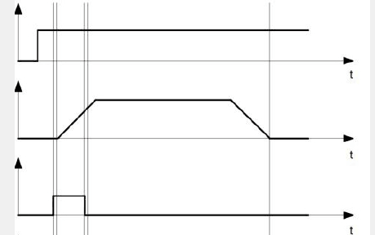

object point
(0x602E,4)

Current speed

New target point
(0x602E 1 bit 4)

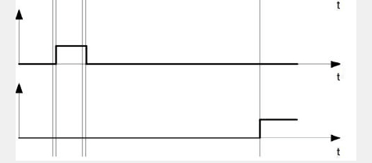
Target point
confirmation
(0x602e,2 bit 12)

Reach the target
Point
(0x602e,2 bit 10)

Other running commands can be stored in the cache (see point in time 1 in the figure below), and bit 12 in the status word object (602e, 2 sets the target point response) will be set to "0". During the motion to the target position, a second target position can be sent to the controller to prepare for it. At this point, you can reset all parameters, such as velocity, acceleration, deceleration, etc. (point in time 2). If the cache is idle again, the next point in time can enter the queue (point in time 3).
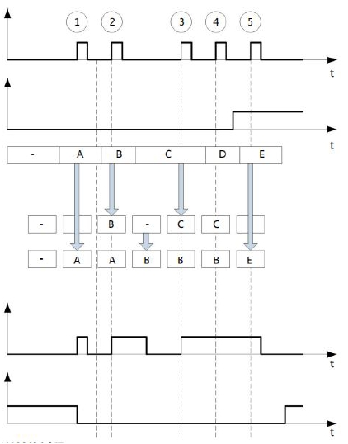
If the cache is full, the new target point will be ignored (point in time 4). If bit 5 in the control word object (602e, 1 bit: "change the target point now") is set, the controller will not use cache when working, and the new running command will be executed directly (point in time 5).

New target point
(0x602e,1 bit 4)

Accept changes
immediately(602e,
1 bit 5)

object point
(602e,4)

Saved target point
Target point to be
processed

Target point
confirmation
(0x602e,2 bit 12)

Reach the target
Point(602e,2 bit 10)

The conversion process of the second target position:
The following figure shows the conversion process of the second target position when moving to the first target position. In this figure, the bit 5 of the control word object (602e, 1) is set to "1" and the new target value will be accepted immediately.

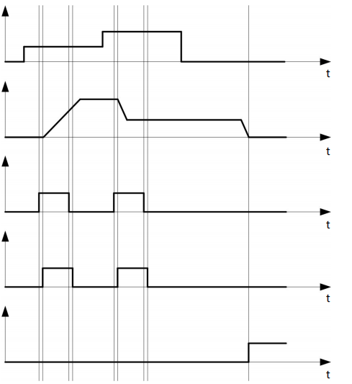

object point
(602e,4)

Current speed

New target point
(602e,4 bit 4)

Target point
confirmation
(602e,2 bit 12)

Reach the target
Point(602e,2 bit 10)

The method of moving to the target position:
If the bit 9 in the control word object (602e,1) is a "0", it will first fully travel to the current target position. In this example, the final speed of the first target position is equal to zero. If bit 9 is set to "1", the final speed will be maintained until the target position is reached, and then the newly set motion parameters will take effect.
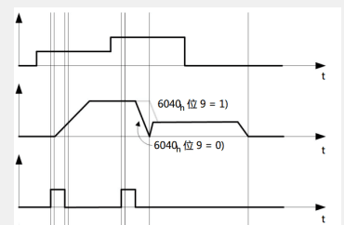

object point
(602e,4)

Current speed

New target point
(602e,4 bit 4)

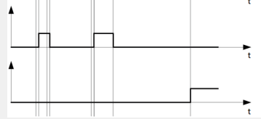
Target point
confirmation
(602e,2 bit 12)

Reach the target
Point(602e,2 bit 10)

Synchronous position Motion mode
Object name | Synchronous position Motion control
Instruct address | 0x601D
Object type | Record
Storage type | RAM
Default value | 2
The synchronous positioning motion mode is the method of absolute immediate execution of the PP mode, by sending broadcast commands, so that the control in the specified group has set the task, and the synchronous stop is also used in the same way.
Before use, you need to switch the running mode to PP mode, set the group (group ID, 2006H) of the controller to be run to a unified value, and then write the running speed and absolute position in the registers of the synchronous positioning speed and synchronous positioning position, that is, set the motion task. After the setting is completed, the NMT broadcast command to let the specified group of controllers run synchronously.

SP speed
Sub-index 0x01: Synchronized location speed
Object type | S32,rw
Range | -2147483648-2147483647
Default value | 0

SP position
Sub-index 0x02: Synchronized location position
Object type | S32,rw
Range | -2147483648-2147483647
Default value | 0

Synchronous start and stop
PMC006C3 is an extension of the NMT instructions of the standard CANOpen to realize the synchronous start and stop of two or more nodes in a network.
Standard NMT format
COB-ID | Byte0 | Byte1
0x000 | CS | Node-ID
The expanded NMT directive adds new definitions of Byte0 and Byte1 without affecting the standard protocol.
Byte0 is defined as follows:
Command | Function
10 | Start the synchronous positioning movement

Byte1 is the group ID, and the corresponding command operation will be executed only when the group ID received by the controller matches its own group ID. Start using NMT command to send, the first data is the function command, 10 is the start synchronous positioning, so the first parameter is 0A, the second parameter is the group id, if it is 1, it is 01.cob-id is 000.

Taking site 3 as an example, the sending instruction is set to run synchronously:
Set group ID 603 2f 06 20 00 01 00 00 00
Set sport mode 603 2f 05 60 00 04 00 00 00
Set the synchronous positioning speed 603 23 1d 60 01 00 7d 00 00
Set the synchronous location 603 23 1d 60 02 00 7d 00 00
Start the synchronous motion 000 0A 01

Analog positioning
PMC006C3 has an analog signal input port, and the internal 12-bit ADC, can be configured into analog positioning mode through software. First configure the analog positioning related parameters, and finally turn on the analog positioning enable. The following quart describes the analog related objects in detail.

Object name | Analog positioning setting
Instruct address | 0x602f
Object type | Record
Storage type | ROM
Reference number | 6

Analog positioning enabled
Subindex 0x01: Analog Positioning Enable, 1 On, 0 Off
Object type | U8, rw
Range | 0,1
Default value | 0

Analog initial AD code

Subindex 0x02: The starting AD code of the analog quantifier, which corresponds to the minimum value of the analog position
Object type | U16, rw
Range | 0-4096
Default value | 0

Analog adjustment interval
Subindex 0x03: Analog adjustment interval, Unit ms
The controller checks the analog input value at this time, and if the difference between the AD input value and the last input value is greater than the threshold value, the position will be adjusted once.
Object type | U16,rw
Range | 0-65535
Default value | 100

Analog regulating trigger value
Subindex 0x04: The analog quantity adjusts the trigger value, and when the difference between the acquired AD code and the last acquired AD code is converted to a position greater than this value, the controller will adjust the position once.
Object type | U16,rw
Range | 0-65535
Default value | 30

Minimum value of analog position
Subindex 0x05: Absolute position corresponding to the analog start AD code
Object type | S32,rw
Range | -2^31~2^31
Default value | 0

Maximum value of analog position
Subindex 0x06: The absolute position corresponding to the AD code of 4095
Object type | S32,rw
Range | -2^31~2^31
Default value | 64000

offline programming

Offline programming parameter 1
Object name | Offline programming parameter 1
SDO ID | 0x6018
Object type | Record
Storage type | ROM
Default value | 2

Sub-index 0x01: Number of offline programming data instructions
Object type | U8, rw
Range | 0-100
Default value | 0

Sub-index 0x02: Offline automatic operation enable
Object type | U8, rw
Range | 0,1
Default value | 0
Offline auto operation value definition:
0: Do not enable offline automatic operation
1: Enable offline automatic operation

Offline programming parameter 2
Object name | Offline programming parameter 2
SDO ID | 0x6019
Object type | Record
Storage type | RAM
Default value | 5

Sub-index 0x01: Offline program pointer
Object type | U8, rw
Range | 0-100
Default value | 0

Sub-index 0x02: Offline command
Object type | U32, rw
Range | -
Default value | -
Offline instruction definitions are described in the User-Defined Programs section.

Sub-index 0x03: Save offline instructions
Object type | U16, rw
Range | 0,1
Default value | 0
Write 1 to save all the offline instructions
Sub-index 0x04: Run instructions
Object type | U16, rw
Range | 0,1
Default value | 0
Write 1 to the instruction pointed to by the pointer of the offline program

Brake control
Support brake control, output duty cycle software is adjustable, avoid the problem of long-term power generation and serious heat generation of brakes.
Object name | Brake control
SDO ID | 0x6016
Object type | U8,rw
Range | 0~100
Storage type | RAM
Default value | 0

Analogue input read
The default voltage input is 0-3.3V, and special versions can support 4-20mA or 0-24V analog input, 12-bit ADC.
Object name | Analogue input
SDO ID | 0x602B
Object type | U16,rw
Range | 0~4095
Storage type | RAM
Default value | 0

Step notification
The controller can set the step notification in position mode or speed mode, that is, when the motor movement reaches a certain set position in a step, the controller can report the step to position notification through TPDO, and supports two step notification position points.
Object name | Step notification
SDO ID | 0x602C
Object type | Record
Storage type | RAM
Default value | 3

Sub-index 0x01: Step notification status
Object type | U8, rw
Range | bit
Default value | 0
The direction of each IO port is represented by 1 bit, 0 is the input, 1 is the output, and the meaning is as follows:
Bit0: Step notification position point 1 is valid;
Bit1: Step notification position point 2 is valid;
The object can be mapped to the TPDO, and when the object value changes, it will be automatically reported to the host computer.

Sub-index 0x02: Step notification position1(absolute setting) setting
Object type | S32, rw
Range | -2147483647 ~ +2147483647
Default value | 0

Sub-index 0x03: Step notification position2(absolute setting) setting
Object type | S32, rw
Range | -2147483647 ~ +2147483647
Default value | 0

Low-voltage protection
The controller detects the power loss of the system and can set the corresponding low voltage protection. The following describes the objects related to the low voltage protection settings in detail.
Object name | low voltage protection setting
SDO ID | 0x6031
Object type | Record
Storage type | ROM
Reference number | 3

Low-voltage protection control word
Sub-index 0x01: low voltage protection control switch
Object type | U16, rw
Range | bit
Default value | 0
Bit0: Offline when the input supply voltage is detected to be below the set value
Bit1: Brake tightening when the input supply voltage is detected to be below the set value
If the corresponding bit bit is 1, it will be enabled, and if it is 0, it will be turned off.

Offline voltage threshold
Sub-index 0x02: Offline threshold voltage, unit mV
Object type | U16, rw
Range | 0-65535
Default value | 0
When the low-voltage offline enable is turned on, the motor goes off when the supply voltage is detected below this voltage.

Brake voltage threshold
Sub-index 0x03: Brake threshold voltage, unit mV
Object type | U16, rw
Range | 0-65535
Default value | 0
When the low-voltage brake enable is turned on, the motor goes off when the supply voltage is detected below this voltage.

User-defined programs
PMC006C3 controller can be configured to work offline, in which the controller automatically executes user-defined program code after powering on, which is pre-compiled and programmed into EEPROM by CQPUSI tool software.
When the PMC006C3 controller is working offline, the CAN communication interface can still respond to the user's online instructions.
The maximum number of user instructions supported by PMC006CX controller is 100.
For detailed examples of user-defined programs, please refer to the Controller Custom Programming Guide.

Tool software operation introduction
PMC006C3 can be used for command debugging, IO port setting detection, stepper motor parameter debugging and custom programming through the CQPUSI tool software PUSICAN. The tool software usage process is tested, and details can be found in the "Pusican Operation Guide".

Graphic programming support
The PUSICAN debugging tool software supports graphical programming, adding process items through the interface, and setting relevant motion parameters to complete simple movements.
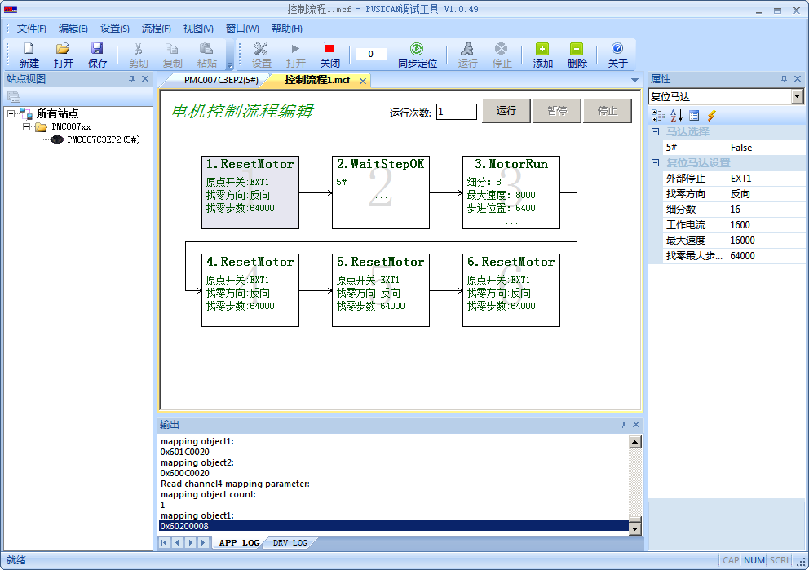

Scripting language support
PUSICAN debugging tool software supports LUA scripting language and has built-in CANOPEN SDO operation functions, which users can call directly in the script program. You can create or open a script file by clicking the "New" and "Open" icons in the upper left corner, and once the script program is written, you can control the program execution through the "Run" and "Stop" icons in the upper right corner. Figure 6-9 below.
The syntax of LUA scripting language is similar to that of C language, and in application scenarios without special UI interface requirements, users can easily complete complex control loop tasks with the help of the powerful functions of LUA scripting without developing the CANOPEN master program in the host computer.
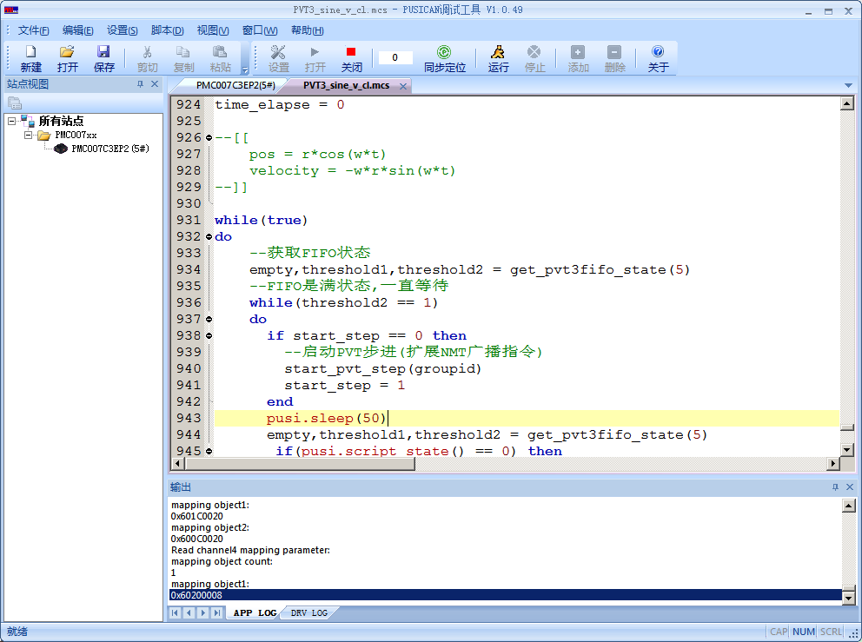

Electrical Characteristics
Parameter | Condition | Min | Typical | Max | Unit
Input Voltage | Normal 25℃ | 9 | 24 | 36 | V
Operation Temperature | 12V input voltage | -20 |  | 85 | ℃
IO maximum current | source/sink current | 0 |  | 20 | mA
Output current | Normal 25℃ | 0 | 2.5 | 3 | A

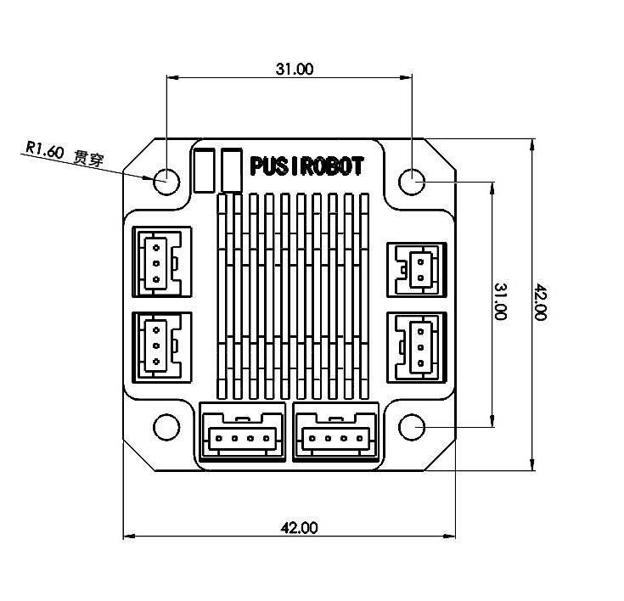
Dimensions

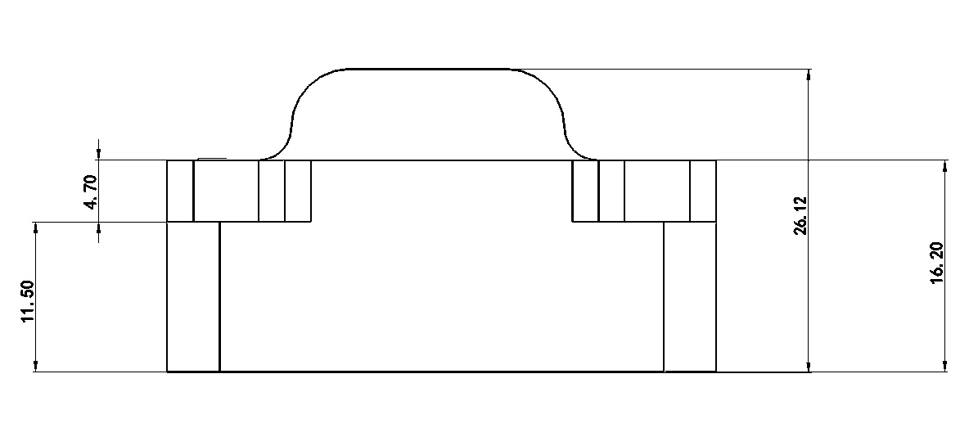

Appendix 1 PMC006C3 Object dictionary table
Index | Sub index | Object type | Name | Type | Attr. | PDO | Storage type
1000h | -- | VAR | Device type | UINT32 | RO | NO | ROM
1001h | -- | VAR | Error registor | UINT8 | RO | Optional | RAM
1002h | -- | VAR | manufacturer status register | UINT32 | RO | Optional | RAM
1003h | -- | ARRAY | pre-defined error field | -- | -- | -- | RAM
1003h | 0h | ARRAY | number of errors | UINT8 |  | NO
1003h | 1h-7h | ARRAY | standard error field |  |  | Optional
1005h | -- | VAR | COB-ID SYNC | UINT32 | RW | NO | ROM
1006h | -- | VAR | communication cycle period | UINT32 | RW | NO | ROM
1007h | -- | VAR | synchronous window length | UINT32 | RW | Optional | ROM
1008h | -- | VAR | manufacturer device name | Visible String | const | NO | ROM
1009h | -- | VAR | manufacturer hardware version | Visible String | const | NO | ROM
100ah | -- | VAR | manufacturer software version | Visible String | const | NO | ROM
1014h | -- | VAR | COB-ID Emergency message | UINT32 | RO | NO | ROM
1015h | -- | VAR | Inhibit Time EMCY | UINT16 | RW | NO | ROM
1016h | -- | ARRAY | Consumer Heartbeat Time | -- | -- | -- | ROM
1016h | 0h | ARRAY | number entries | UINT8 | RO | NO
1016h | 1h-3h | ARRAY | Consumer Heartbeat Time | UINT32 | RW | NO
1017h | -- | VAR | Producer Heartbeat Time | UINT16 | RW | NO | ROM
1018h | -- | RECORD | Identity Object | -- | -- | -- | ROM
1018h | 0h | RECORD | number of entries | UINT8 | RO | NO
1018h | 1h | RECORD | Vendor ID | UINT32 | RO | NO
1018h | 2h | RECORD | Product code | UINT32 | RO | NO
1018h | 3h | RECORD | Revision number | UINT32 | RO | NO
1018h | 4h | RECORD | Serial number | UINT32 | RO | NO
1200h | -- | RECORD | Server SDO parameter | -- | -- | -- | ROM
1200h | 0h | RECORD | number of entries | UINT8 | RO | NO
1200h | 1h | RECORD | COB-ID Client->Server (rx) | UINT32 | RO | NO
1200h | 2h | RECORD | COB-ID Server -> Client (tx) | UINT32 | RO | NO
1200h | 3h | RECORD | Node-ID of the SDO client | UINT32 | RW | NO
1280h | -- | RECORD | Client SDO parameter | -- | -- | -- | RAM
1280h | 0h | RECORD | number of entries | UINT8 | RO | NO
1280h | 1h | RECORD | COB-ID Client->Server (tx) | UINT32 | RW | NO
1280h | 2h | RECORD | COB-ID Server -> Client (rx) | UINT32 | RW | NO
1280h | 3h | RECORD | Node-ID of the SDO server | UINT32 | RW | NO
1400h | -- | RECORD | receive PDO parameter | -- | -- | -- | ROM
1400h | 0h | RECORD | largest sub-index supported | UINT8 | RO | NO
1400h | 1h | RECORD | COB-ID used by PDO | UINT32 | RW | NO
1400h | 2h | RECORD | transmission type | UINT8 | RW | NO
1400h | 3h | RECORD | inhibit time | UINT16 | RW | NO
1400h | 4h | RECORD | compatibility entry | UINT8 | RW | NO
1400h | 5h | RECORD | event timer | UINT16 | RW | NO
1401h | -- | RECORD | receive PDO parameter | -- | -- | -- | ROM
1401h | 0h | RECORD | largest sub-index supported | UINT8 | RO | NO
1401h | 1h | RECORD | COB-ID used by PDO | UINT32 | RW | NO
1401h | 2h | RECORD | transmission type | UINT8 | RW | NO
1401h | 3h | RECORD | inhibit time | UINT16 | RW | NO
1401h | 4h | RECORD | compatibility entry | UINT8 | RW | NO
1401h | 5h | RECORD | event timer | UINT16 | RW | NO
1402h | -- | RECORD | receive PDO parameter | -- | -- | -- | ROM
1402h | 0h | RECORD | largest sub-index supported | UINT8 | RO | NO
1402h | 1h | RECORD | COB-ID used by PDO | UINT32 | RW | NO
1402h | 2h | RECORD | transmission type | UINT8 | RW | NO
1402h | 3h | RECORD | inhibit time | UINT16 | RW | NO
1402h | 4h | RECORD | compatibility entry | UINT8 | RW | NO
1402h | 5h | RECORD | event timer | UINT16 | RW | NO
1403h | -- | RECORD | receive PDO parameter | -- | -- | -- | ROM
1403h | 0h | RECORD | largest sub-index supported | UINT8 | RO | NO
1403h | 1h | RECORD | COB-ID used by PDO | UINT32 | RW | NO
1403h | 2h | RECORD | transmission type | UINT8 | RW | NO
1403h | 3h | RECORD | inhibit time | UINT16 | RW | NO
1403h | 4h | RECORD | compatibility entry | UINT8 | RW | NO
1403h | 5h | RECORD | event timer | UINT16 | RW | NO
1600h | -- | RECORD | receive PDO mapping | -- | -- | -- | ROM
1600h | 0h | RECORD | number of mapped application objects in PDO | UINT8 | RO | NO
1600h | 1h-8h | RECORD | PDO mapping for the nth application object to be mapped | UINT32 | RW | NO
1601h | -- | RECORD | receive PDO mapping | -- | -- | -- | ROM
1601h | 0h | RECORD | number of mapped application objects in PDO | UINT8 | RO | NO
1601h | 1h-8h | RECORD | PDO mapping for the nth application object to be mapped | UINT32 | RW | NO
1602h | -- | RECORD | receive PDO mapping | -- | -- | -- | ROM
1602h | 0h | RECORD | number of mapped application objects in PDO | UINT8 | RO | NO
1602h | 1h-8h | RECORD | PDO mapping for the nth application object to be mapped | UINT32 | RW | NO
1603h | -- | RECORD | receive PDO mapping | -- | -- | -- | ROM
1603h | 0h | RECORD | number of mapped application objects in PDO | UINT8 | RO | NO
1603h | 1h-8h | RECORD | PDO mapping for the nth application object to be mapped | UINT32 | RW | NO
1800h | -- | RECORD | transmit PDO parameter | -- | -- | -- | ROM
1800h | 0h | RECORD | largest sub-index supported | UINT8 | RO | NO
1800h | 1h | RECORD | COB-ID used by PDO | UINT32 | RW | NO
1800h | 2h | RECORD | transmission type | UINT8 | RW | NO
1800h | 3h | RECORD | inhibit time | UINT16 | RW | NO
1800h | 4h | RECORD | reserved | UINT8 | RW | NO
1800h | 5h | RECORD | event timer | UINT16 | RW | NO
1801h | -- | RECORD | transmit PDO parameter | -- | -- | -- | ROM
1801h | 0h | RECORD | largest sub-index supported | UINT8 | RO | NO
1801h | 1h | RECORD | COB-ID used by PDO | UINT32 | RW | NO
1801h | 2h | RECORD | transmission type | UINT8 | RW | NO
1801h | 3h | RECORD | inhibit time | UINT16 | RW | NO
1801h | 4h | RECORD | reserved | UINT8 | RW | NO
1801h | 5h | RECORD | event timer | UINT16 | RW | NO
1802h | -- | RECORD | transmit PDO parameter | -- | -- | -- | ROM
1802h | 0h | RECORD | largest sub-index supported | UINT8 | RO | NO
1802h | 1h | RECORD | COB-ID used by PDO | UINT32 | RW | NO
1802h | 2h | RECORD | transmission type | UINT8 | RW | NO
1802h | 3h | RECORD | inhibit time | UINT16 | RW | NO
1802h | 4h | RECORD | reserved | UINT8 | RW | NO
1802h | 5h | RECORD | event timer | UINT16 | RW | NO
1803h | -- | RECORD | transmit PDO parameter | -- | -- | -- | ROM
1803h | 0h | RECORD | largest sub-index supported | UINT8 | RO | NO
1803h | 1h | RECORD | COB-ID used by PDO | UINT32 | RW | NO
1803h | 2h | RECORD | transmission type | UINT8 | RW | NO
1803h | 3h | RECORD | inhibit time | UINT16 | RW | NO
1803h | 4h | RECORD | reserved | UINT8 | RW | NO
1803h | 5h | RECORD | event timer | UINT16 | RW | NO
1a00h | -- | RECORD | transmit PDO mapping | -- | -- | -- | ROM
1a00h | 0h | RECORD | number of mapped application objects in PDO | UINT8 | RO | NO
1a00h | 1h-8h | RECORD | PDO mapping for the n-th  application object to be mapped | UINT32 | RW | NO
1a01h | -- | RECORD | transmit PDO mapping | -- | -- | -- | ROM
1a01h | 0h | RECORD | number of mapped application objects in PDO | UINT8 | RO | NO
1a01h | 1h-8h | RECORD | PDO mapping for the n-th  application object to be mapped | UINT32 | RW | NO
1a02h | -- | RECORD | transmit PDO mapping | -- | -- | -- | ROM
1a02h | 0h | RECORD | number of mapped application objects in PDO | UINT8 | RO | NO
1a02h | 1h-8h | RECORD | PDO mapping for the n-th  application object to be mapped | UINT32 | RW | NO
1a03h | -- | RECORD | transmit PDO mapping | -- | -- | -- | ROM
1a03h | 0h | RECORD | number of mapped application objects in PDO | UINT8 | RO | NO
1a03h | 1h-8h | RECORD | PDO mapping for the n-th  application object to be mapped | UINT32 | RW | NO
2002h | -- | VAR | Node ID | UINT8 | RW | NO | ROM
2003h | -- | VAR | Baud rate | UINT8 | RW | NO | ROM
2006h | -- | VAR | Group ID | UINT8 | RW | NO | ROM
2007h | -- | VAR | System control | UINT8 | RW | NO | RAM
6000h | -- | VAR | Error state | UINT8 | RW | Optional | RAM
6001h | -- | VAR | Controller status | UINT8 | RW | Optional | RAM
6002h | -- | VAR | Rotation direction | UINT8 | RW | NO | RAM
6003h | -- | VAR | Max speed | UINT32 | RW | NO | RAM
6004h | -- | VAR | Step command | UINT32 | RW | NO | RAM
6005h | -- | VAR | Operation mode | UINT8 | RW | NO | RAM
6006h | -- | VAR | Start speed | UINT16 | RW | NO | ROM
6007h | -- | VAR | Stop speed | UINT16 | RW | NO | ROM
6008h | -- | VAR | Acceleration coefficient | UINT8 | RW | NO | ROM
6009h | -- | VAR | Deceleration coefficient | UINT8 | RW | NO | ROM
600ah | -- | VAR | Microstepping | UINT16 | RW | NO | ROM
600bh | -- | VAR | Max phase current | UINT16 | RW | NO | ROM
600ch | -- | VAR | Motor position | UINT32 | RW | Optional | RAM
600dh | -- | VAR | Current attenuation | UINT8 | RW | NO | ROM
600eh | -- | VAR | Motor enable | UINT8 | RW | NO | RAM
600fh | -- | RECORD | External emergency stop | UINT8 | RW | NO | ROM
600fh | 0h | RECORD | The number of parameters | UINT8 | RO | NO | ROM
600fh | 1h | RECORD | External emergency stop enable | UINT8 | RW | NO | RAM
600fh | 2h | RECORD | Trigger mode of external emergency stop | UINT8 | RW | NO | RAM
6010h | -- | RECORD | PVT step | UINT8 | RW | NO | ROM
6010h | 0h | RECORD | The number of parameters | UINT8 | RO | NO | ROM
6010h | 1h | RECORD | PVT operation control | UINT8 | RW | NO | RAM
6010h | 2h | RECORD | PVT mode control | UINT8 | RW | NO | RAM
6010h | 3h | RECORD | Max PVT point number | UINT16 | RW | NO | RAM
6010h | 4h | RECORD | PVT pointer | UINT16 | RO | NO | ROM
6010h | 5h | RECORD | Start index of PVT mode 1 | UINT16 | RW | NO | RAM
6010h | 6h | RECORD | End index of PVT mode 1 | UINT16 | RW | NO | RAM
6010h | 7h | RECORD | Start index of PVT model 2 acceleration stage | UINT16 | RW | NO | RAM
6010h | 8h | RECORD | End index of PVT model 2 acceleration stage | UINT16 | RW | NO | RAM
6010h | 9h | RECORD | Start index of PVT model 2 cycle stage | UINT16 | RW | NO | RAM
6010h | Ah | RECORD | End index of PVT model 2 cycle stage | UINT16 | RW | NO | RAM
6010h | Bh | RECORD | The times of PVT model 2 cycle stage | UINT16 | RW | NO | RAM
6010h | Ch | RECORD | Start index of PVT model 2 deceleration stage | UINT16 | RW | NO | RAM
6010h | Dh | RECORD | End index of PVT model 2 deceleration stage | UINT16 | RW | NO | RAM
6010h | Eh | RECORD | FIFO depth of PVT mode 3 | UINT16 | RW | NO | RAM
6010h | Fh | RECORD | FIFO lower limit of PVT mode 3 | UINT16 | RW | NO | RAM
6010h | 10h | RECORD | FIFO upper limit of PVT mode 3 | UINT16 | RW | NO | RAM
6010h | 11h | RECORD | PVT position | INT32 | RW | NO | RAM
6010h | 12h | RECORD | PVT speed | INT32 | RW | NO | RAM
6010h | 13h | RECORD | PVT time | INT32 | RW | NO | RAM
6011h | -- | RECORD | GPIO parameter | -- | -- | -- | ROM
6011h | 0h | RECORD | The number of GPIO parameters | UINT8 | RO | NO
6011h | 1h | RECORD | GPIO direction | UINT16 | RW | NO
6011h | 2h | RECORD | GPIO configuration | UINT32 | RW | NO
6012h | -- | VAR | GPIO value | UINT16 | RW | Optional | RAM
6013h | -- | RECORD | OCP parameter(ROM) | -- | -- | --
6013h | 0h | RECORD | OCPNumber of parameters | UINT8 | RO | NO
6013h | 1h | RECORD | OCT1 | UINT8 | RW | NO
6013h | 2h | RECORD | OCD1 | UINT8 | RW | NO
6016h | -- | VAR | Brake control | UINT8 | RW | NO | RAM
6017h |  |  | Stall parameter(open loop) | UINT8 | RW |  | ROM
6018h | -- | RECORD | Off-line programming parameter 1 | -- | -- | -- | ROM
6018h | 0h | RECORD | Number of Off-line programming parameter 1 | UINT8 | RO | NO
6018h | 1h | RECORD | Total number of offline programming command | UINT8 | RW | NO
6018h | 2h | RECORD | Offline operation enable automatically | UINT8 | RW | NO
6019h | -- | RECORD | Off-line programming parameter 2 | -- | -- | -- | RAM
6019h | 0h | RECORD | Number of Off-line programming parameter 2 | UINT8 | RO | NO
6019h | 1h | RECORD | Off-line parameter pointer | UINT8 | RW | NO
6019h | 2h | RECORD | Off-line command | UINT32 | RW | NO
6019h | 3h | RECORD | Offline command preservation | UINT8 | RW | NO
6019h | 4h | RECORD | Run current command | UINT8 | RW | NO
601ah | -- | VAR | Jitter delay of external emergency stop | UINT16 | RW | NO | ROM
601bh | -- | VAR | Locked-Rotor configuration | UINT8 | RW | NO | ROM
601ch | -- | VAR | Absolute position step | INT32 | RW | NO | RAM
601dh | -- | RECORD | PV step | -- | -- | -- | RAM
601dh | 0h | RECORD | The number of PV step parameter | UINT8 | RO | NO
601dh | 1h | RECORD | PV speed | INT32 | RW | NO
601dh | 2h | RECORD | PV position | INT32 | RW | NO
6020h | -- | VAR | Termination step | UINT8 | RW | NO | RAM
6021h | -- | VAR | Encoder CPR | UINT16 | RW | NO | ROM
6022h | -- | VAR | Position saving value  power-down | INT32 | RO | NO | ROM
6023h | -- | VAR | Closed-loop parameter KP | UINT8 | RW | NO | ROM
6024h | -- | VAR | Closed-loop parameter KI | UINT8 | RW | NO | ROM
6025h | -- | VAR | Closed-loop parameter KD | UINT8 | RW | NO | ROM
6026h | -- | VAR | Closed-loop Pre-filter parameter | INT8 | RW | NO | ROM
6027h | -- | VAR | Closed-loop post-filter parameter | INT16 | RW | NO | ROM
6028h | -- | VAR | Closed-loop stall length | INT16 | RW | NO | ROM
6029h | -- | VAR | Enable closed-loop torque loop | UINT8 | RW | NO | ROM
602Ah | -- | VAR | Enable saving automatically when power is off | UINT8 | RW | NO | ROM
602Bh | -- | VAR | Analogue input | UINT16 | RW | Optional | RAM
602Ch | -- | RECORD | Step notification | -- | -- | -- | RAM
602Ch | 0h | RECORD | Number of parameters | UINT8 | RO | NO
602Ch | 1h | RECORD | Step notification status | UINT8 | RW | Optional
602Ch | 2h | RECORD | Step notification position 1 | INT32 | RW | Optional
602Ch | 3h | RECORD | Step notification position 2 | INT32 | RW | Optional
602Dh | -- | RECORD | PP/PVmode parameters 1 | -- | -- | -- | ROM
602Dh | 0h |  | Number of parameters | UINT8 | RO | NO
602Dh | 1h |  | PP Accelerated speed | UINT32 | RW | Optional
602Dh | 2h |  | PP Dccelerated speed | UINT32 | RW | Optional
602Dh | 3h |  | PP Initial speed | UINT32 | RW | Optional
602Dh | 4h |  | PP Stop speed | UINT32 | RW | Optional
602Eh | -- | RECORD | PP/PVmode parameters 2 | -- | -- | -- | RAM
602Eh | 0h |  | Number of parameters | UINT8 | RO | NO
602Eh | 1h |  | PP control word | UINT16 | RW | Optional
602Eh | 2h |  | PP status word | UINT16 | RW | Optional
602Eh | 3h |  | PP running speed | INT32 | RW | Optional
602Eh | 4h |  | PP target location | INT32 | RW | Optional
602Fh | -- | RECORD | Analog location parameters | -- | -- | -- | ROM
602Fh | 0h |  | Number of parameters | UINT8 | RO | NO
602Fh | 1h |  | Enable analog positioning | UINT8 | RW | Optional
602Fh | 2h |  | Analog initial AD code | UINT16 | RW | Optional
602Fh | 3h |  | Analog adjustment interval time | UINT16 | RW | Optional
602Fh | 4h |  | Analog regulating trigger value | UINT16 | RW | Optional
602Fh | 5h |  | Minimum value of analog position | INT32 | RW | Optional
602Fh | 6h |  | Maximum value of analog position | INT32 | RW | Optional
6030h | -- | VAR | real-time speed | INT32 | RW | Optional | RAM
6031h | -- | RECORD | power-down behavior control | -- | -- | -- | ROM
6031h | 0h |  | Number of parameters | UINT8 | RO | NO
6031h | 1h |  | Power-down behavior control word | UINT16 | RW | Optional
6031h | 2h |  | Power off motor enabling threshold | UINT16 | RW | Optional
6031h | 3h |  | Brake lock threshold | UINT16 | RW | Optional
6034h | -- | VAR | Calibration zero position | INT32 | RW | NO | ROM
6035h | -- | VAR | Encoder position | INT32 | RW | Optional | RAM
6033h | -- | VAR | Running direction control | U8 | RW | Optional | ROM
6014h | -- | VAR | Temperature threshold setting | U8 | RW | Optional | ROM

Appendix 2 CANopen Communication Examples

SDO Read/Write Examples

SDO Read

Data frame format

Master send:
600+ServNodeID | 0 | 40 | Index | Subindex | 00 | 00 | 00 | 00
Index,SubIndex——Index and subindex values in the object dictionary in the node 1 of the data to be read

600——Command word for receiving message
ServNodeID——ID Node of the node 1
40——Command word for requesting to read data
0——Standard frame
1——Extended frame

00 00 00 00——Data area

Slave response:
When the data length is 1 byte
580+ServNodeID | 0 | 4F | Index | Subindex | d0 | 0 | 0 | 0
When the data length is 2 bytes
580+ServNodeID | 0 | 4B | Index | Subindex | d0 | d1 | 0 | 0
When the data length is 3 bytes
580+ServNodeID | 0 | 47 | Index | Subindex | d0 | d1 | d2 | 0
When the data length is 4 bytes
580+ServNodeID | 0 | 43 | Index | Subindex | d0 | d1 | d2 | d3

SDO Read example
Master send: 605 40 01 60 00 00 00 00 00
Slave response: 585 4F 01 60 00 08 00 00 00
The master initiated a read request to the device whose node ID is 5. The index and subindex of the request are 0x6001 and 0x00 respectively, which corresponds to controller status parameter in the PMC007 Object Dictionary. The slave response 4F indicates that the parameter length is one byte, the data is 0x08 and the device is in busy state.

SDO Write in

Data frame format
Master send:
When the data length is 1 byte
600+ServNodeID | 0 | 2F | Index | Subindex | d0 | 0 | 0 | 0
When the data length is 2 byte
600+ServNodeID | 0 | 2B | Index | Subindex | d0 | d1 | 0 | 0
When the data length is 3 byte
600+ServNodeID | 0 | 27 | Index | Subindex | d0 | d1 | d2 | 0
When the data length is 4 byte
600+ServNodeID | 0 | 23 | Index | Subindex | d0 | d1 | d2 | d3

Correct response from the slave station:
580+ServNodeID | 0 | 60 | Index | Subindex | 00 | 00 | 00 | 00
Index, Subindex——Index and subindex values in the object dictionary in the node 3 of the data to be read

580——Send SDO
ServNodeID——ID Node of the node 3
60—Command word for response to write data successfully
0——Standard frame
1——Extended frame

00 00 00 00——Data area

Error response from the slave station:

580+ServNodeID | 0 | 80 | Index | Subindex | SDO abort code error
SDO abort code error——According to the error, the code is different. For details see Appendix 4

Index, Subindex——Index and subindex values in the object dictionary in the node 3 of the data to be read

80—Command word for response

0——Standard frame
1——Extended frame

580——Command word for sending message
ServNodeID——ID Node of the node 3

Note: Abort code error SDO returns the corresponding parameters according to the specific error. The specific parameters are shown in Appendix 4.

SDO Write example
Master send: 605 2F 03 20 00 07 00 00 00
Slave response: 585 60 03 20 00 00 00 00 00
The master initiated a write request to the device whose node ID is 5. The index and subindex of the request are 0x2003 and 0x00 respectively, which corresponds to the baud rate setting parameter in the PMC007 Object Dictionary. and the write data is 7, which indicates the baud rate is set to 800Kbit/s. The slave response 60 indicates the data is written successfully.

Master send: 605 23 04 60 00 80 0C 00 00
Slave response: 585 80 04 60 00 22 00 00 08
The master initiated a write request to the device whose node ID is 5. The index and subindex of the request are 0x6004 and 0x00 respectively, which corresponds to the step command parameter in the PMC007 Object Dictionary. and the write data is C80(3200), which indicates that the motor performs 3200 steps. The slave response 60 indicates the data is written unsuccessfully, and error code is 0x08000022. See Appendix 4 we can know that the error code indicates that the data cannot be transferred or saved to the application due to the current device status. Check whether the controller status parameter is that the external stop is enabled and whether there is an error in the error state.

Appendix 3 PDO configuration example

PDO overview
PDO communication is based on the Producer/Consumer model, which is mainly used to transfer real-time data. The node which generated data puts the data with its own node ID on the bus, and nodes which need the data can be configured to receive the data sent by the node. The transmission of PDO is triggered by the event, which can represent a change in a PDO variable and can also be a time of expiration or a specific message to be received. Process data is transmitted directly in an CAN message without a protocol header file. The length of a PDO is between 0 and 8 bytes.
PDOs is included in the mapping parameter and communication parameter. PMC007xx supports 4 PDOs.

The structure PDO——Mapping parameter
A PDO in the Object Dictionary consists of adjacent items. The mapping parameters define the connection of these items. A mapping parameter defines a data source through an index, a subindex, and a number of bits.
For example:
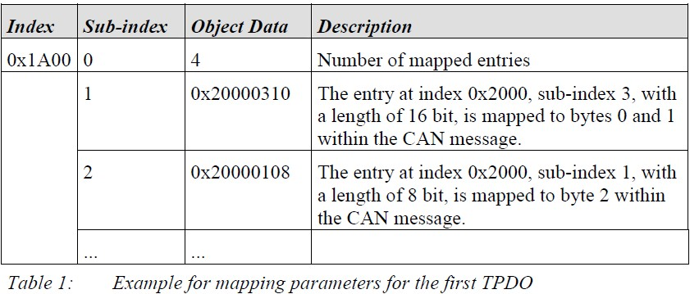
A CAN message has not more than 8 bytes. This means that there can send 8 object items at most when there is only one PDO used.
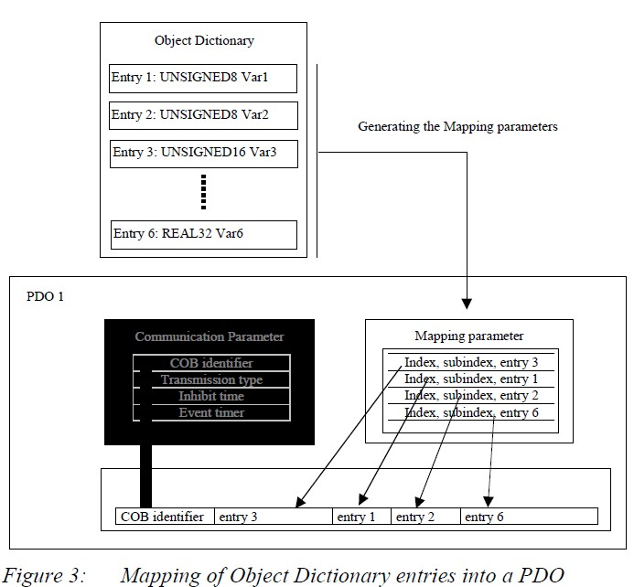

The structure PDO——Communication parameter
In order to transmit a PDO, the communication parameter defines the nature of the transport and the CAN identifier.
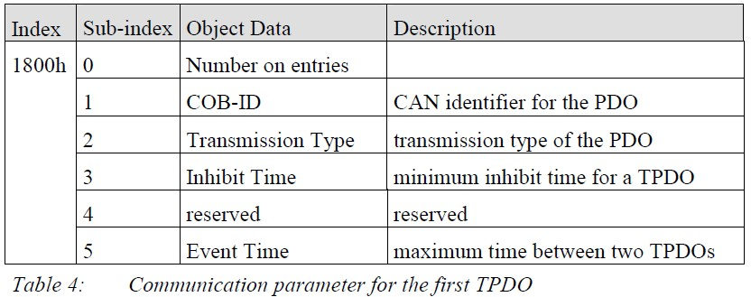
PDO communication parameter is an item in the Object Dictionary.
(RPDOs: index 0x1400–0x15FF,TPDOs: 0x1800-0x19FF)
If allowed, the communication parameter can be modified by the CAN with the help of the data service object.

COB-ID(CAN identifier. Subindex 1)
COB-ID as proof of identity, the priority of PDO is before the bus access. For every CAN message, there is only one sender (producer). However, it allows multiple recipients (consumers) for the existing message.
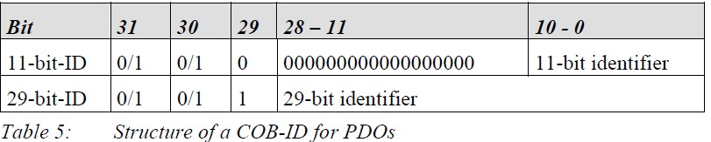
The thirtieth bit is 0, which indicates that a remote transmission request (RTR) is allowed for this PDO.
PDO COB-ID distribution:
PDO1(send) | 181H-1FFH
PDO1(receive) | 201H-27FH
PDO2(send) | 281H-2FFH
PDO2(receive) | 301H-37FH
PDO3(send) | 381H-3FFH
PDO3(receive) | 401H-47FH
PDO4(send) | 481H-4FFH
PDO4(receive) | 501H-57FH

PDO Trigger mode
Sending of PDO can be triggered by the following methods:
1) Event trigger.
2) Time trigger.
3) Single query.
4) Synchronization.
When only use event to trigger the sending of PDO, once the event process is changed, the PDO is sent. It may bring very serious consequences, that is, when the frequency of a process data change is very high, the PDO is sent uninterruptedly , that will cause the message of other nodes is not sent out, which seriously affect the efficiency of the bus.
CANopen uses the " Inhibit time " mechanism to solve this problem. Inhibit time is a configurable time period in units of 100 us. The same PDO sends at least this time interval, so it can determine the maximum transmission frequency of an event triggered PDO.
Generally, the sending of PDO can be triggered by a combination of any of the trigger mode. But the most common way is to combine the Event trigger and Time trigger. In the case of single event trigger, since process data did not change for a long time (such as temperature variables), the PDO have not been triggered for a long time. It will affect the nodes just joined the network. So if plus time triggered mode, PDO is forced to send again within the stipulated time. For example, for a PDO, the inhibition time is configured as 5, event timer is configured as 250, so the PDO can be sent when process data changes. The minimal interval of sending is 5ms, on the other hand, no matter whether there is no change in the data, the PDO will be sent every 250ms.
Configuration of PDO trigger mode is realized through setting subindex 2 in the Object Dictionary of PDO communication parameter. The range of the subindex is 0-255 The following lists the different values for different trigger modes.
0: PDO is sent after SYNC is received, but not cycle.
1-240: PDO is sent periodically after SYNC is received . The value is the number of SYNC between two send of PDO .
255：Event trigger.

PDO Configuration example
PMC007xx supports PDO mapping by SDO configuration. To configure the GPIO value to be TPDO1 as an example, the SDO is sent as:
Set the COB-ID of communication to 187, which means that the device with node ID 7 receives this PDO
Sent by the main station: 607 23 00 18 01 87 01 00 80
Clear channel information
Main station sending: 607 2F 00 1A 00 00 00 00 00 00
Set as event triggered
Main station sending: 607 2F 00 18 02 FF 00 00 00 00
Set the Inhibit time to 5ms
Sent by the main station: 607 2B 00 18 03 32 00 00 00
Set the Event time to 1000ms
Sent by the main station: 607 2B 00 18 05 E8 03 00 00
Set mapping parameters to map 0x6012 to TPDO1
Main station sending: 607 23 00 1A 01 10 00 12 60
Set the mapping channel TPDO2 parameter to 0
Sent by the main station: 607 23 00 1A 02 00 00 00 00 00
Set the mapping channel TPDO3 parameter to 0
Main station sending: 607 23 00 1A 03 00 00 00 00 00
Set the number of mapping entries 1
Main station sending: 607 2F 00 1A 00 01 00 00 00
Resend communication site information
Sent by the main station: 607 23 00 18 01 83 01 00 00After the configuration is completed, PMC007 will send PDO message every 1s. When the of value GPIO port is changed, PMC007 will also issue the message.
187 03 00
The message indicates that GPIO1 and GPIO2 are both high level.

Appendix 4 SDO abort code error

Abort code | Code function description
05030000 | No alternation of trigger bits
05040000 | SDO protocol timeout
05040001 | Illegal or unknown Client/Server command word
05040002 | Invalid block size (only Transfer Block mode)
05040003 | Invalid serial number (only Transfer Block mode)
05030004 | CRC error (only Transfer Block mode)
05030005 | Out of memory
06010000 | Access is not supported for the Object.
06010001 | Try to read write-only objects
06010002 | Try to write read-only objects
06020000 | Object does not exist in the Object Dictionary
06040041 | Object cannot be mapped to PDO
06040042 | The number and length of the mapped object exceeds the PDO length
06040043 | General parameters are not compatible
06040047 | General equipment is not compatible
06060000 | Hardware error causes the object access failure
06060010 | Data type does not match, and service parameter length does not match
06060012 | Data type does not match, the service parameter is too large
06060013 | Data type does not match, the service parameter is too small
06090011 | The subindex does not exist
06090030 | Beyond the range of the parameter values (when write access)
06090031 | Parameter value is written too large
06090032 | Parameter value is written too small
06090036 | The maximum value is less than the minimum value
08000000 | General error
08000020 | Data cannot be transferred or saved to applications
08000021 | Due to local control, data cannot be transferred or saved to applications
08000022 | Due to the current device status, data cannot be transferred or saved to applications
08000023 | The dynamic condition of Object dictionary generates error or Object Dictionary does not exist

